BUSINESS ENVIRONMENT

What is Business?
It is a continuous production and distribution of goods and services with the aim of earning profits under uncertain market conditions.
It is a form of regular activity conducted with an objective of earning profits for the benefit of those on whose behalf the activity is conducted.
OBJECTIVES OF BUSINESS
- Profit,
- Growth,
- Customer Satisfaction,
- Employee Satisfaction,
- Quality products and services,
- Market Leadership
- Employment creation,
- Service to Society.

BUSINESS ENVIRONMENT
Business environment consists of individuals, institutions and other forces which are outside the control of a business but that potentially affect It’s performance.
CHARACTERISTICS OF BUSINESS ENVIRONMENT
Business environment is complex in nature.
It is constantly changingprocess.
It is different fordifferent business units.
It has both long term and short term impact.
Unlimited influence of externalenvironment factors.
It is very uncertain.
Inter-related components.
It includes both internaland external environment.

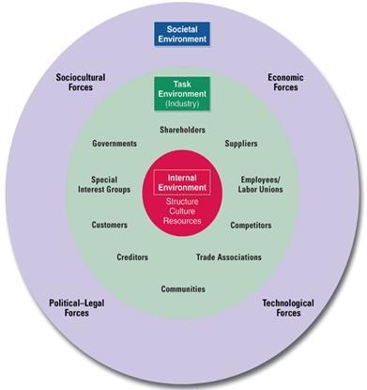

Types of Business Environment
Mainly Business Environment divided into two types. These are:
Internal Environment
External Environment
Internal Environment
The factors which can be controlled by company or
Primary factors which directly affect the growth of organization….. men, material, money, machines and management.

TYPES OF INTERNAL ENVIRONMENT
Value System
Mission & Objectives
Management Structure and Nature
Internal Power relationship
Human Resources
Company Image and Brand Equity,
External Environment
Those factors which are beyond the control of business enterprise are included in external environment.
External Environment Divided into two parts:
Micro Environment: The environment which is close to the business and affects its capacity to work is known as Micro Environment.
Macro Environment: It includes factors that create opportunities and threats to business units. Following are the elements of Macro Environment.

  - Micro Environment.
Suppliers
Customers
Wholesalers
Retailers
Industries
Government and Other Institutions
Market Intermediaries
Middleman
Marketing Agencies
Financial Intermediaries
Physical Intermediaries
Competitors
Public
Macro Environment
Economic Environment: It is very complex and dynamic in nature that keeps on changing with the change in policies or political situations. It has three elements:
Economic Conditions of Public
Economic Policies of the country
Economic System
Other Economic Factors: Infrastructural Facilities, Banking, Insurance companies, money markets, capital markets etc
Non-Economic Environment:
Following are included in non-economic environment:
Political Environment: It affects different
business units extensively. Components are
Political Belief of Government
Political Strength of the Country
Relation with other countries
Defense and Military Policies
Centre State Relationship in the Country
Thinking Opposition Parties towards Business Unit

Socio-Cultural Environment
Influence exercised by social and cultural factors, not within the control of business, is known as Socio-Cultural Environment.

These factors include: attitude of people to work,
system, caste system, religion, education, marriage etc.
Technological Environment
A systematic application of scientific knowledge to practical task is known as technology.

Natural Environment
It includes natural resources, weather, climatic conditions, port facilities, topographical factors such as soil, sea, rivers, rainfall etc.
Every business unit must look for these factors before choosing the location for theirbusiness.

Demographic Environment
It is a study of perspective of population i.e. its size, standard of living, growth rate, age-sex composition, family size, income level (upper level, middle level and lower level), education level etc.
Every business unit must see these features of population and recognize their various needs and produce accordingly.
Everyday there has been vast changes in products, services, lifestyles and living conditions, these changes must be analysed by every business unit and should adapt these changes.

International Environment
It is particularly important for industries directly depending on import or exports.
The factors that affect the business are
Globalization
Liberalization
Foreign business policies
Cultural exchange
Components of Business Environment

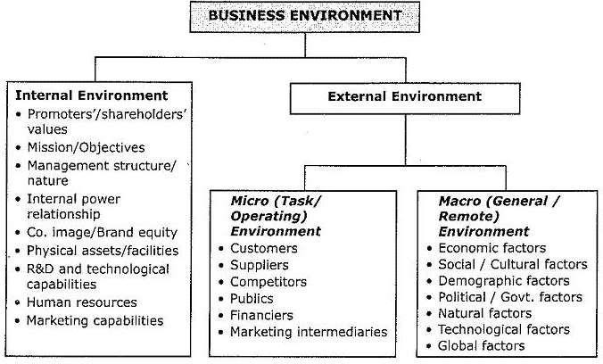

Business Environment for Successful Entrepreneurship in Kenya
1. Introduction
Kenya is one of Africa’s leading entrepreneurial hubs, often referred to as the "Silicon Savannah" due to its innovation in mobile technology and digital finance. The country provides both opportunities and challenges for entrepreneurs. A supportive environment fosters business success, while constraints can hinder entrepreneurial growth.

2. Components of Kenya’s Business Environment
a) Internal Factors (controlled by entrepreneurs)
- Access to human capital – Kenya has a young, educated, and innovative workforce.
- Finance management – Entrepreneurs rely on microfinance, SACCOs, mobile money, and venture capital.
- Innovation – Adoption of mobile apps (e.g., M-Pesa, Tala, Little Cab).
b) External Factors (outside the entrepreneur’s control)
- Economic Environment
  - Kenya’s economy is diverse, with agriculture, ICT, and services leading.
  - Inflation and high interest rates sometimes limit access to affordable credit.
  - Government initiatives like Hustler Fund and Youth Enterprise Development Fund help SMEs.
- Political and Legal Environment
  - Stable governance but bureaucratic hurdles remain.
  - The Kenya Investment Authority (KenInvest) promotes entrepreneurship.
  - Policies like Vision 2030 and Kenya Startup Bill (2022) aim to improve the business climate.
- Socio-Cultural Environment
  - Kenyans have a strong entrepreneurial culture, often driven by the need for self-employment.
  - Consumer behavior is shifting toward digital services and convenience-based solutions.
- Technological Environment
  - Kenya leads in mobile money innovation (M-Pesa).
  - High internet penetration supports e-commerce (Jumia, Kilimall) and digital startups.
  - Government’s Konza Technopolis project promotes ICT-driven enterprises.
- Competitive Environment
  - High competition in retail, transport (matatus, ride-hailing), and agribusiness.
  - Startups compete with multinational firms entering the market.
- Global Environment
  - Kenya benefits from trade blocs like East Africa Community (EAC) and African Continental Free Trade Area (AFCFTA) , expanding market access.
  - Opportunities exist in export markets for tea, coffee, and horticulture.

3. Importance of a Conducive Environment in Kenya
- Encourages job creation (SMEs contribute over 80% of employment).
- Attracts foreign direct investment (FDI).
- Supports innovation in fintech, agritech, and renewable energy.
- Builds Kenya’s global competitiveness as an entrepreneurship hub in Africa.

4. Challenges Facing Entrepreneurs in Kenya
- High cost of electricity and production.
- Limited access to affordable financing.
- Bureaucracy in licensing and taxation.
- Corruption and regulatory inconsistencies.
- Inadequate infrastructure in rural areas.

5. Strategies for Successful Entrepreneurship in Kenya
- Leverage technology – e-commerce, mobile apps, and fintech solutions.
- Networking and mentorship – incubation hubs like iHub, Nailab, and Gearbox.
- Exploit government incentives – Hustler Fund, Ajira Digital Program.
- Adopt innovation and value addition – e.g., processing agricultural products for export.
- Environmental scanning – staying alert to policy and market changes.

